**DAILY ONLINE ACTIVITIES SUMMARY**

|  |  |  |  |  |  |  |  |  |
| --- | --- | --- | --- | --- | --- | --- | --- | --- |
| **Date:** | **15/08/2020** | | | | | **Name:** | **Spoorthy Balaji** | |
| **Sem & Sec** | **6th & B** | | | | | **USN:** | **4al17cs098** | |
| **Online Test Summary** | | | | | | | | |
| **Subject** | | **-** | | | | | | |
| **Max. Marks** | | **-** | | **Score** | | | **-** | |
| **Certification Course Summary** | | | | | | | | |
| **Course** | Introduction to Cybersecurity Tools & Cyber Attacks | | | | | | | |
| **Certificate Provider** | | | **Coursera** | | **Duration** | | | **4Weeks** |
| **Coding Challenges** | | | | | | | | |
| **Problem Statement: Python program to copy odd lines of one file to other** | | | | | | | | |
| **Status: Solved** | | | | | | | | |
| **Uploaded the report in Github** | | | | | **yes** | | | |
| **If yes Repository name** | | | | | <https://github.com/spoorthybalaji/Daily_Status> | | | |
| **Uploaded the report in slack** | | | | | **yes** | | | |

**ONLINE COURSE**

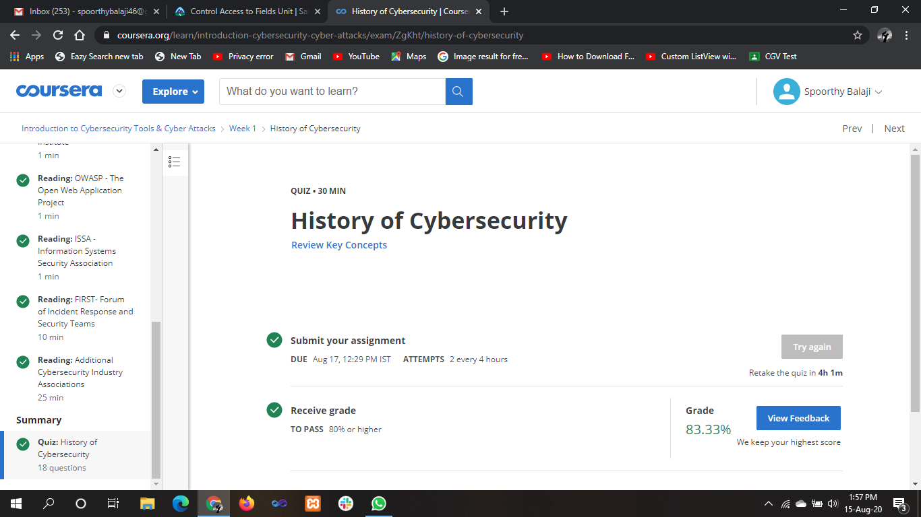

**ONLINE** **CODING**

**Python program to copy odd lines of one file to other**

fn = open('file1.txt', 'r')

fn1 = open('file2.txt', 'w')

cont = fn.readlines()

type(cont)

for i in range(0, len(cont)):

if(i % 2 ! = 0):

fn1.write(cont[i])

else:

pass

fn1.close()

fn1 = open('file2.txt', 'r')

cont1 = fn1.read()

print(cont1)

fn.close()

fn1.close()

Output : Python